1. **Notes and Scripts**

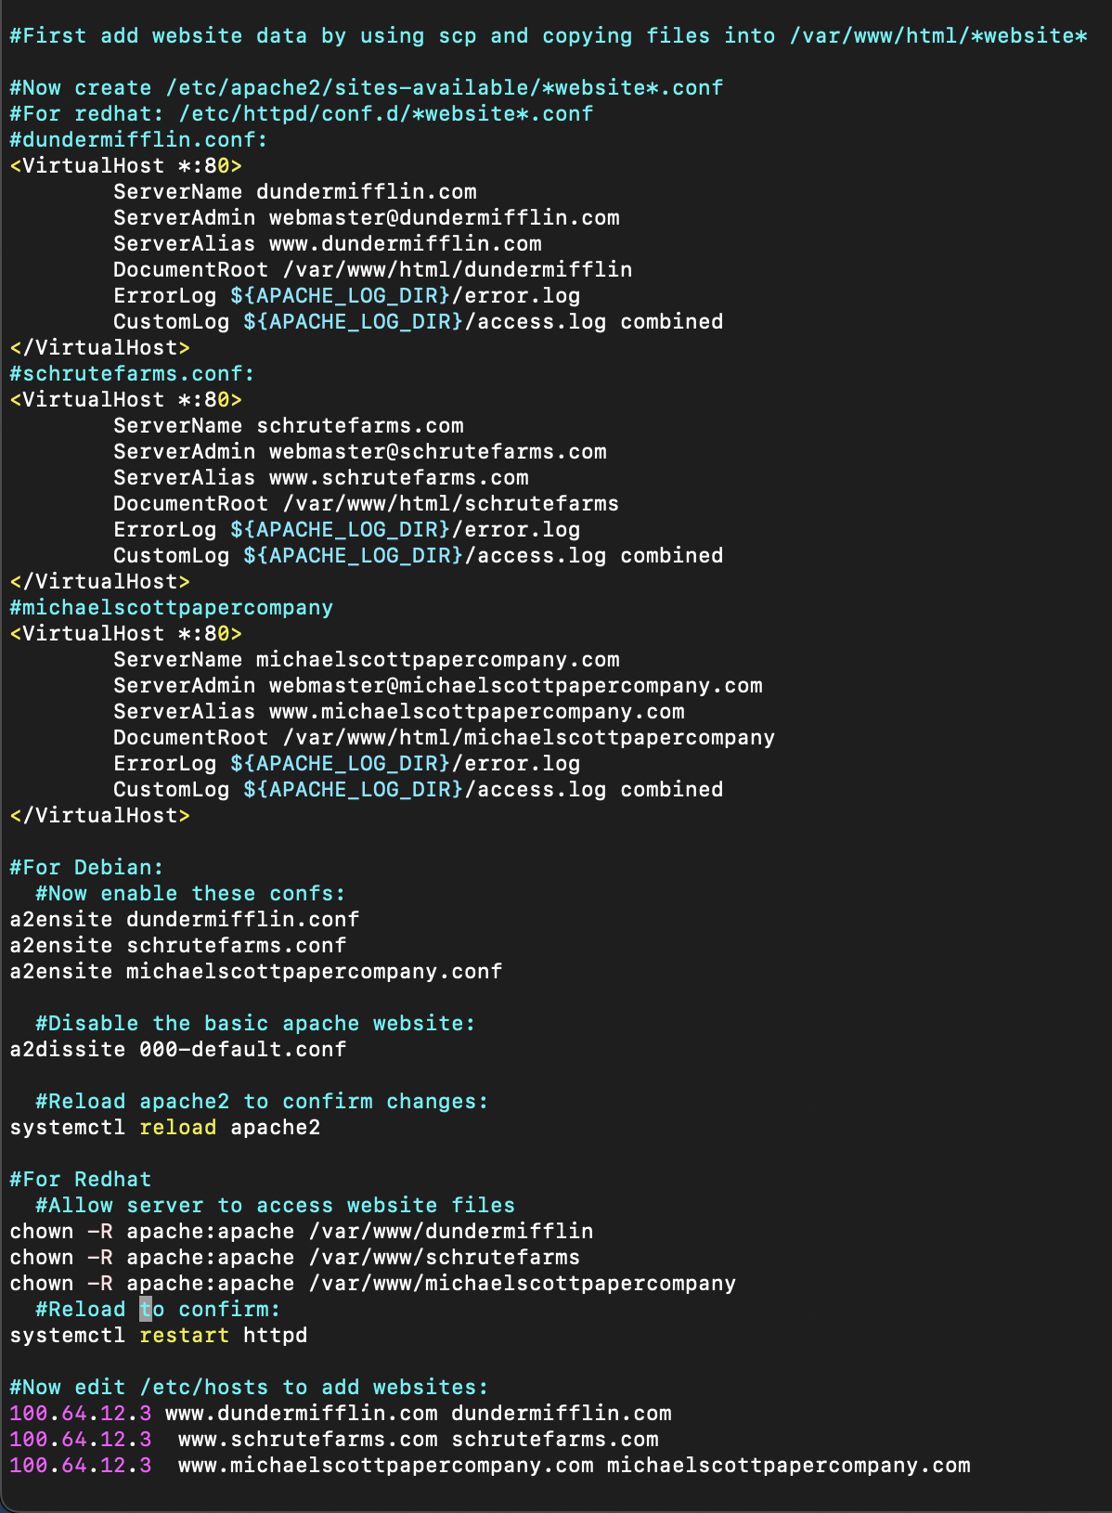

This script above shows how I installed the web servers for the three websites on Debian and redhat. There are some basic notes on what the commands do, but here is my general thinking. I copied the unzipped .tgz files into the html directory and created conf files so the websites would work. I then enabled the websites and created a DNS like entry in /etc/hosts. The Debian vs redhat commands were a bit different, initially I had to chown permission to apache on redhat to allow the server to read all the files. Other than that it was pretty straight forward. This is not a direct script, but these are the commands I used to set the servers up and is used as a note reference file.

For the cron jobs on machine c, I used this command in the crontab file:

*/5 * * * * rsync -aH 100.64.12.3:/var/www/html/dundermifflin/* /var/www/html/dundermifflin

*/5 * * * * rsync -aH 100.64.12.3:/var/www/html/schrutefarms/* /var/www/html/schrutefarms

*/5 * * * * rsync -aH 100.64.12.3:/var/www/html/michaelscottpapercompany/* /var/www/html/michaelscottpapercompany

To allow ssh without a password and make the rsync command truly autonomous, I used:

Ssh-keygen -t rsa -b 4096

Ssh-copy-id [root@100.64.12.3](mailto:root@100.64.12.3)

1. **Thinking behind users for add and modify on webserver**

Here is the script I used to allow for the three users to modify and add files to the web server. My initial thinking was how could I add permissions to these users only for a specific directory. And I realized we already did that in assignment 3 with Users and the managers/sales/accounting directories. I set up a group for the dundermifflin website and added the users to it. I set the owner permissions to the group and then changed the group permissions for all the files so that users and groups could read and edit. There is an execute for the group permission because the website could not function if the apache server couldn’t execute any of the files.

1. **Testing my web servers**

The main way I tested my web servers was the curl command. The curl commands provided in the hints helped a lot as I just changed the URL input to test the different websites. When I would curl, it would output the html that was on that page, and based on the output, I could see if it was working or not. This helped when I created test.html files to see if the permissions were working and it would spit out the html of that extension.

1. **Approximate time taken:**

12 hours.